9. DATA ANALYSIS BY EXPECTION MAXIMISATION ALGORITHM USING WEKA

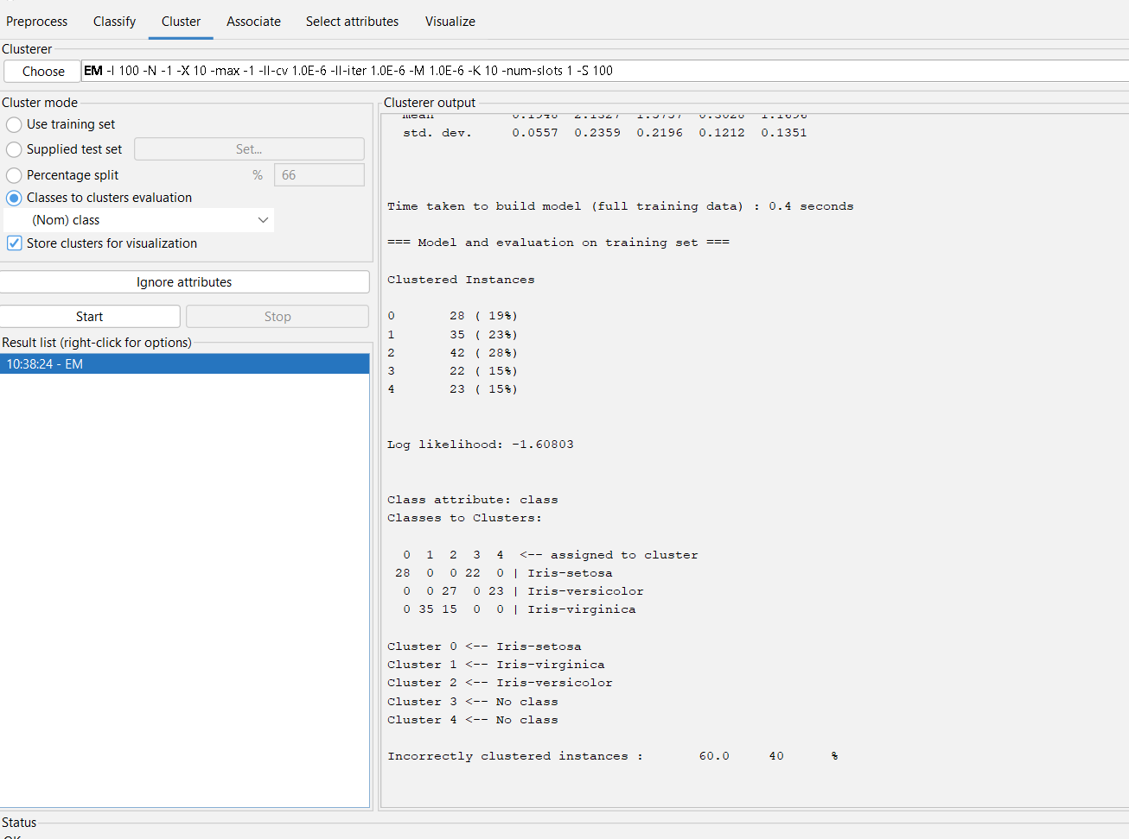

DATA ANALYSIS BY EXPECTATION MAXIMISATION ALGORITHM – OUTPUT INNFO OF IRIS

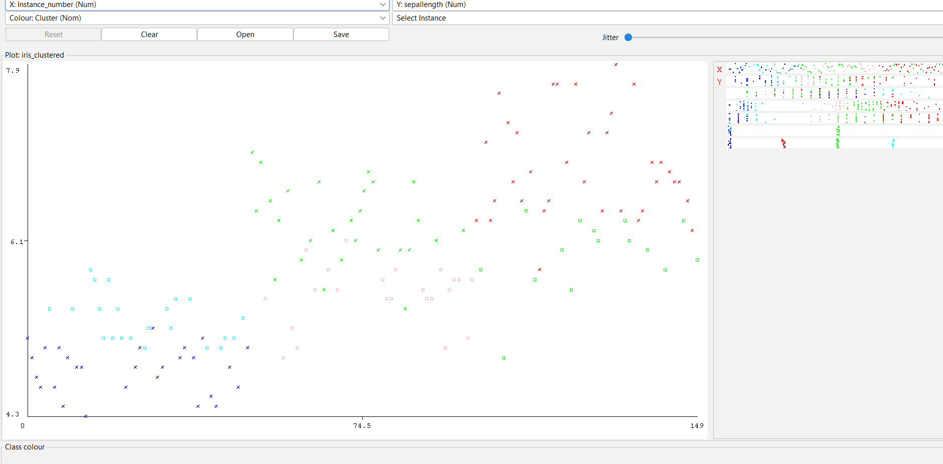

DATA ANALYSIS BY EXPECTATION MAXIMISATION ALGORITHM—PLOT DIAGRAM OF IRIS INFO